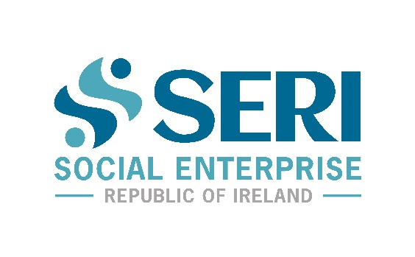
Dear Friends,
As the new Board of Social Enterprise Republic of Ireland (SERI), we are reaching out to introduce ourselves to you and invite you to become part of the new movement we have created to support the Social Enterprise sector in Ireland.
Our organisation was created by Social Enterprises, for Social Enterprises, so that our members guide our path forward, as an organisation, as a network and as a movement. Each member of our board and management team are deeply committed to our mission, which is to support, unite and champion the Social Enterprise sector in Ireland to ensure that it fulfils its potential in terms of impact and sustainability.
We are thrilled to have this opportunity to build a new and stronger Social Enterprise sector together from the bottom-up, working as an inclusive and collaborative union.
Social Enterprise has unlimited potential for creating a new approach to the new normal. We are resilient, innovative and courageous, and together, we will leverage our super-powers to step into the future together, for the benefit of all.
Our Board of directors will consist of at least 51% Social Enterprise Practitioners at all times. In the next few weeks we will be inviting nominations for further practitioner representatives. In addition, we will be setting up a formal Social Enterprise Practitioner Council. We will announce these processes very soon.
Join us, and let us hear what you care about, what challenges you are facing, and how we can help and support you. This is a new era for Social Enterprise, lets create it together.
Find out more about membership benefits and how to join SERI here…
From: The SERI Team
Fergus Finlay, Brendan Whelan, Lorraine Corcoran, John P Murphy, John Kearns, Senan Cooke, Padraig Casey, Larry O’Neill, Karen Leigh, Darren Ryan, Michelle Fogarty, and Tammy Darcy
The Important Details
SERI Website | www.socialenterprise.ie
Email | info@socialenterprise.ie
Phone | 051-871181
Hashtags | #SERI #SocialEnterpriseROI #SERILaunch
Social Media Handle | @SERIreland (for all channels)
Twitter | https://twitter.com/SERIreland
Facebook | https://www.facebook.com/SERIreland
Linkedin | https://www.linkedin.com/company/serireland

